**Assignment 2: Panorama creation**

By

Lakshay Saggi: 2017CS50412

Siddhant Mago: 2017CS50419

**Overview**

More or less, we have followed the approach given in the problem statement.

We have first created a database of key points and descriptors for all the images using SIFT feature detection.

1. After getting the features for all the images, we have calculated the base image, i.e., the image on which all other images will be projected on. To calculate the base image we have, we have followed the following approach:
   1. We first calculate with respect to the first image, the homographies of all the other images
   2. after that, we take the average of the obtained homographies and then the first image votes the image with the minimum least square distance to be taken as the base image
2. We do this process for all the images and the image with most **votes** is taken as the base image
3. After the base image has been calculated, we take the image which is most similar to the base image and stitch that image to the base image.
4. We have blended the images using distance version of alpha blending and we observed very little or no seams in the panorama

**NOTE**: We have also provided a ratio option which is used to crop images if the angle between some are very high, the results obtained are with ratio = 0.7. Ratio = 1 means no cropping the homographies are performed as is.

**Results**

**Dataset-1**

**Dataset-2**

**Dataset-3**

In dataset-3, we didn’t obtain results as expected. We obtained correct results when we stitched 3 images. However, when the 4th image was added the image became very distorted, because of very less matching between that image and remaining three images. The result obtained is shown below:

However, without blending the images we were getting better results

if we **remove blending** it is clearly visible where the error is

**Dataset-4**

**Dataset-5**

We have also handled the stitching of x and y coordinates properly as can be seen in the above result. The stitching is also mostly seamless. However, if we manually inputted base image in this case we get a seamless image:

**Affine Transform Results**

In the affine transform the lines which were initially parallel remain parallel because of which stitched image was raised a little upwards from its actual position

**Out Sample Dataset**

**In which the results were good**

**Sample 1:**

**Result on these images:**

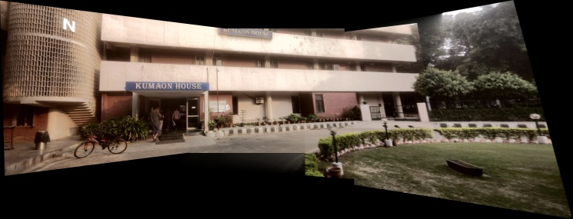

**Sample 2:**

In this we tried to take a difficult image for stitching but the results were still good without any seams

Result:

**In which the results were completely unexpected**

**Sample:**

**Result**

The results were bad because of very minimal matching between images as well as the angle of rotation was very large for only three images and thus the panorama is not properly created.